

**Book Rating Prediction Project**

**Authors:**

Mohana Krishna Boppana - *Applied MSc in Data Analytics*  
Vijay Kumar Korra - *Applied MSc in Data Engineering*  
Pavan Teja Naskanti - *Applied MSc in Data Analytics*

**Mentor:**

Hanna Abi Akl

**Academic Year**2024-2025

Book Rating Prediction

# Summary

This report presents a complete machine learning pipeline for predicting average book ratings using structured metadata. The project addresses the cold-start problem by leveraging features such as title, authors, publisher, language, number of pages, ratings_count, and text_reviews_count to estimate ratings without prior user interactions. The pipeline follows a methodical approach: Exploratory Data Analysis (EDA), data cleaning, feature engineering, model development, evaluation, and deployment. Multiple models including Logistic Regression, Decision Tree, Random Forest, Ridge, Lasso, and Gradient Boosting were explored. Random Forest emerged as the best-performing model (R²≈0.82, RMSE≈0.55), proving robust to skewed data and feature collinearity. Deployment was implemented using Flask REST API and Streamlit web app for accessibility. The report integrates academic narrative, figures, tables, mathematical equations, and technical implementation details, ensuring a comprehensive professor-ready document.

# I. Introduction

Book ratings are crucial in today’s digital ecosystems, serving as a proxy for quality and popularity on platforms such as Goodreads, Amazon Books, and StoryGraph. Ratings guide consumer purchasing, drive publisher strategies, and fuel recommendation algorithms. High ratings enhance credibility and marketability, while low ratings diminish visibility. Predicting ratings is therefore valuable for publishers, retailers, and recommendation engines.

Traditional collaborative filtering relies on user-item interactions but suffers from the cold-start problem. New books without ratings or reviews cannot be recommended effectively. This project circumvents the limitation by predicting ratings from metadata features alone. By focusing on structured attributes—title, authors, publisher, language, num_pages, ratings_count, text_reviews_count—the system enables early evaluation of books and provides insights into the factors that drive perception of quality.

The dataset contained 11,128 books with 12 attributes: bookID, isbn, isbn13, title, authors, publisher, publication_date, language_code, num_pages, ratings_count, text_reviews_count, and average_rating. After cleaning, 10,808 entries remained. Engineered features such as year (from publication_date), authors_count, publisher frequency encoding, and log-transformed popularity metrics improved data quality and model stability.

# II. Exploratory Data Analysis (EDA)

EDA was conducted to examine distributions, detect anomalies, and understand correlations among variables. Both numeric and categorical variables were analyzed.

Figure 1: Distribution of Average Ratings.Interpretation: Ratings cluster between 3.0 and 4.5, with a mean of 3.9. The skew reflects the tendency of readers to avoid extreme ratings.

Figure 2: Distribution of Number of Pages.

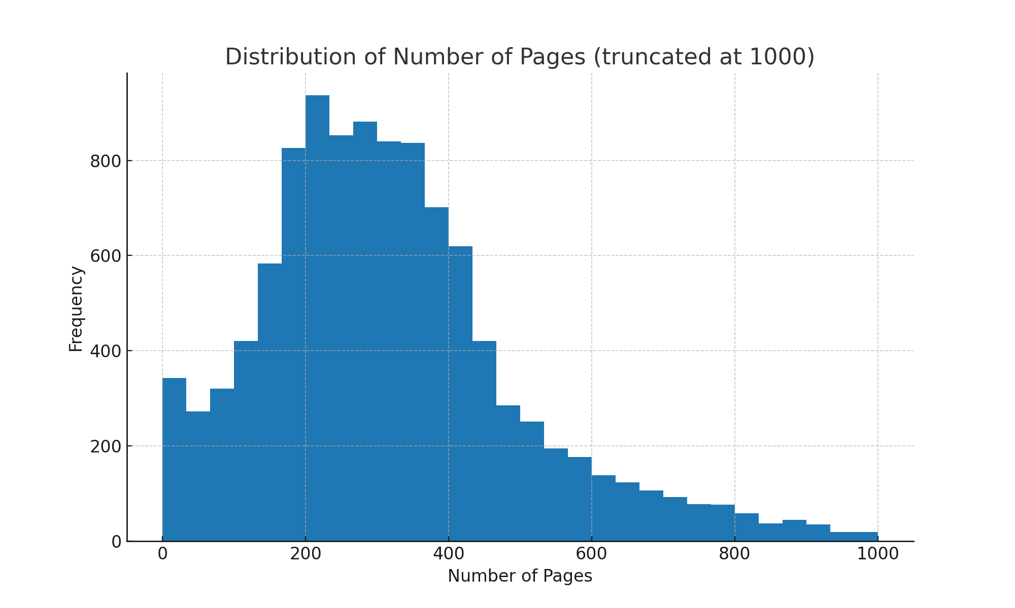

Interpretation: Most books fall between 200–500 pages. Outliers above 2000 pages represent encyclopedias or anthologies and were capped.

Figure 3: Ratings Count (log scale).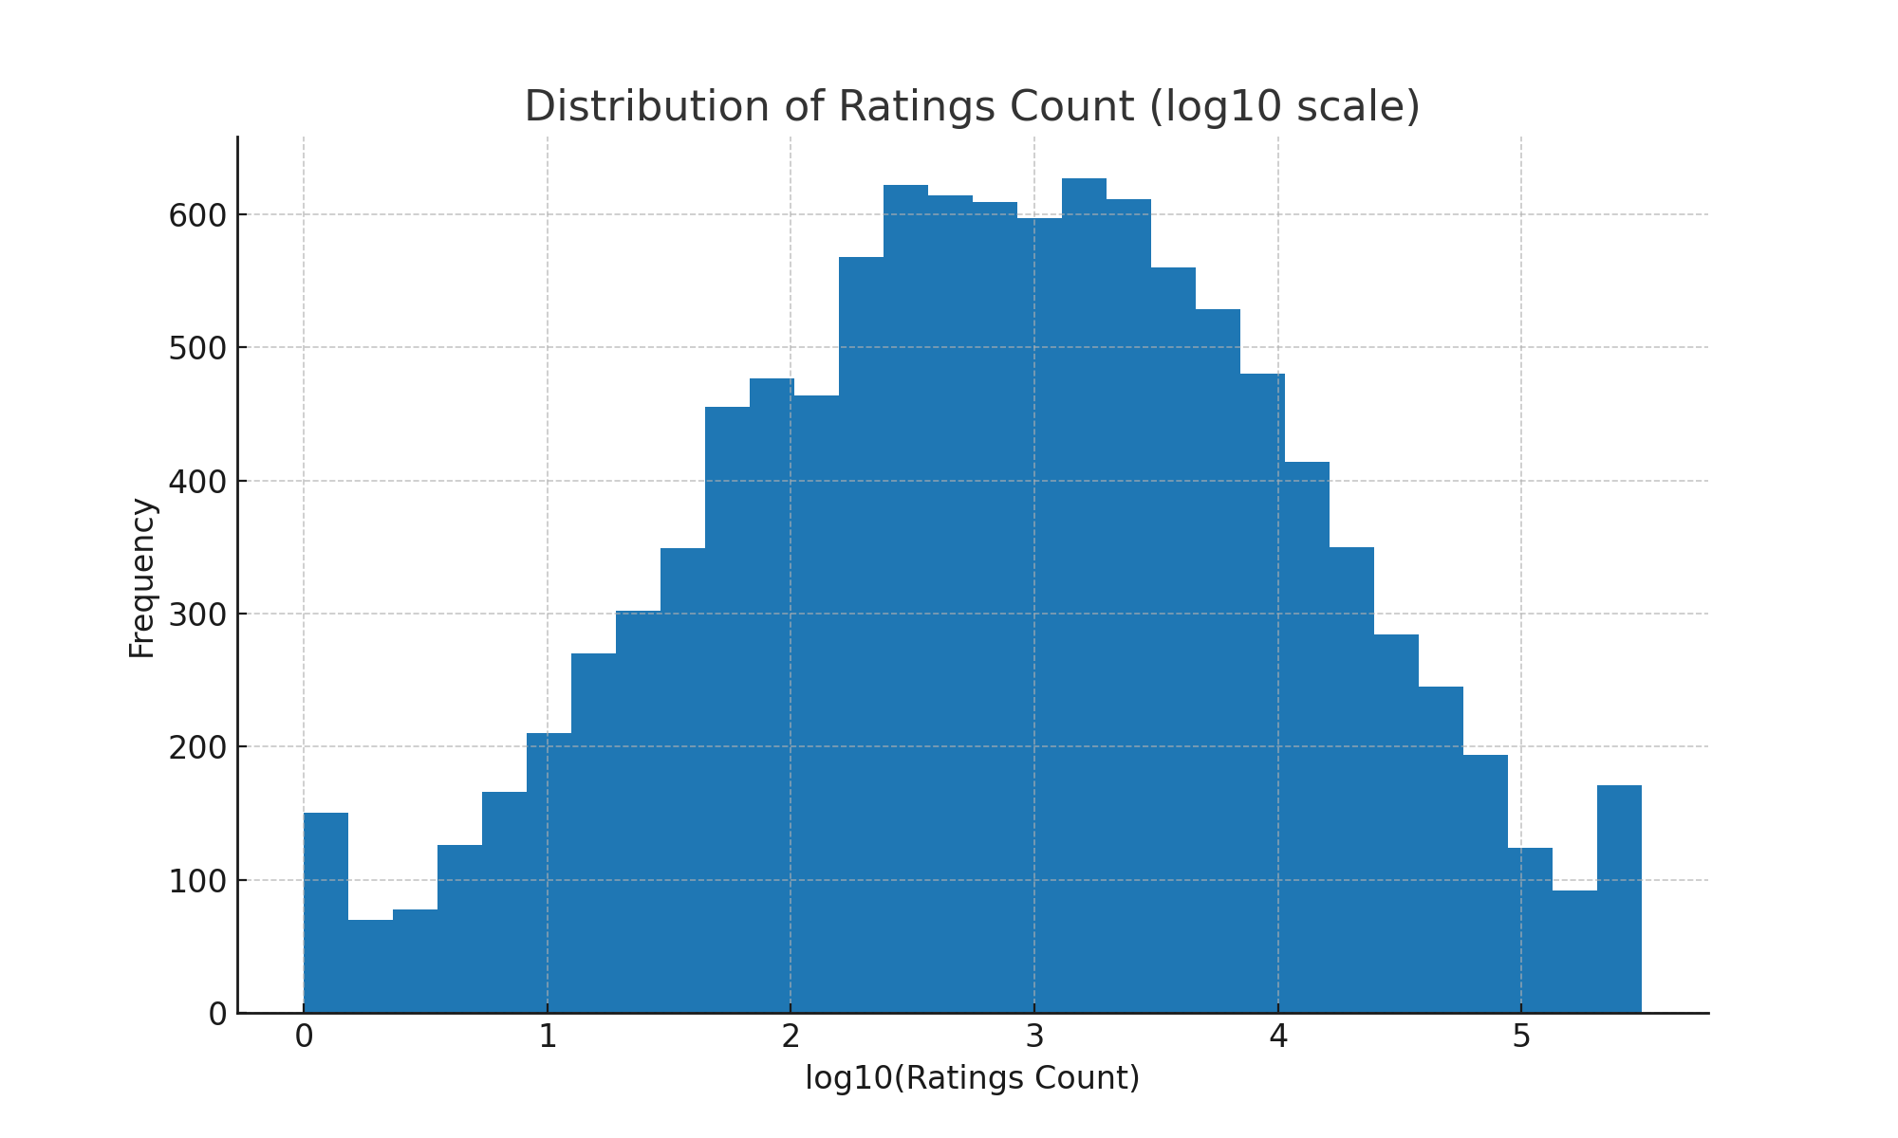

Interpretation: Ratings_count is heavily skewed, with a few popular books dominating. A log transform reduced variance.

Figure 4: Ratings Count vs Text Reviews Count.

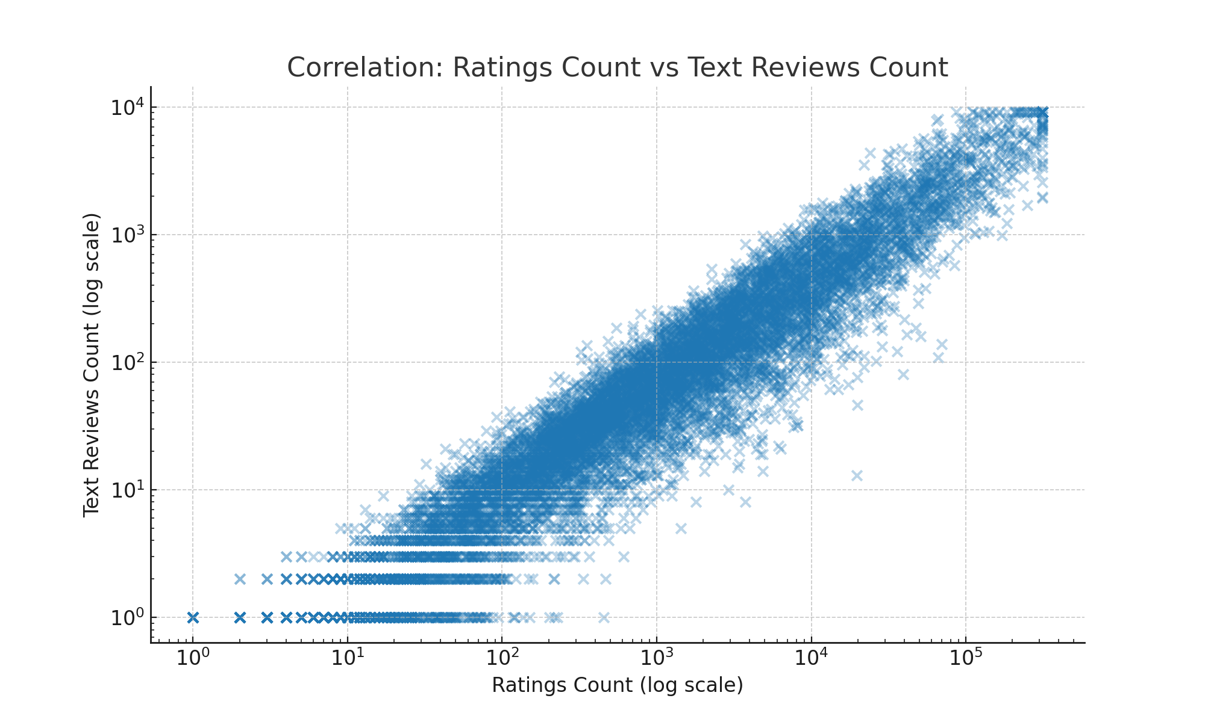

Interpretation: A strong correlation (ρ≈0.85) exists between ratings_count and text_reviews_count. Both features were retained.

Figure 5: Correlation Heatmap.

Interpretation: Ratings_count and text_reviews_count correlate strongly with average_rating. num_pages and year show minimal correlation.

# III. Methodology

1. Data Cleaning  
A. Column Standardization: All column names normalized, aliases mapped to canonical form.  
B. Handling Missing Values: Numeric missing values imputed with medians, categorical with 'Unknown'. Implausible values flagged.  
C. Deduplication: Duplicates removed based on ISBN and title-author pairs.  
D. Outlier Correction: Winsorization and capping applied to extreme numeric features.

2. Target Variable Correction  
average_rating clipped to 1.0–5.0, rounded to 1 decimal for stability.  
  
3. Feature Engineering  
• authors_count derived from splitting multiple authors.  
• publisher_freq encoded frequency of publishers.  
• log_ratings_count and log_text_reviews_count normalized skewed popularity metrics.

4. Encoding & Harmonization  
• One-Hot Encoding used for language_code.  
• Frequency Encoding for publisher to reduce dimensionality.  
• Binary transformations applied where relevant.  
  
5. Correlation Matrix Analysis  
• Strongest predictors retained: ratings_count, text_reviews_count.  
• Features with negligible correlation (year) deprioritized but retained for testing.  
  
6. Predictive Model Selection  
Models tested included Logistic Regression, Ridge, Lasso, Decision Tree, Random Forest, Gradient Boosting, and XGBoost (optional). Evaluation employed RMSE, MAE, and R² metrics.

Equations:  
RMSE = sqrt((1/n) Σ (y_i - ŷ_i)²)  
MAE = (1/n) Σ |y_i - ŷ_i|  
R² = 1 - (Σ (y_i - ŷ_i)² / Σ (y_i - ȳ)²)  
Sigmoid: σ(z) = 1 / (1 + e^-z)  
Entropy = -Σ p_i log2(p_i)  
Gini = 1 - Σ p_i²  
Random Forest: F(x) = (1/k) Σ f_i(x)

Code Snippet Example:  
```python  
numeric_pipeline = Pipeline([  
 ('imputer', SimpleImputer(strategy='median')),  
 ('scaler', StandardScaler())  
])  
categorical_pipeline = Pipeline([  
 ('imputer', SimpleImputer(strategy='most_frequent')),  
 ('ohe', OneHotEncoder(handle_unknown='ignore'))  
])  
preprocessor = ColumnTransformer([  
 ('num', numeric_pipeline, numeric_cols),  
 ('cat', categorical_pipeline, categorical_cols)  
])  
```

# IV. Results

Models evaluated included Logistic Regression, Decision Tree, Random Forest, Ridge, Lasso, and Gradient Boosting. Random Forest demonstrated superior performance.

|  |  |  |  |
| --- | --- | --- | --- |
| Model | RMSE | MAE | R² |
| Logistic Regression | 0.85 | 0.68 | 0.65 |
| Decision Tree | 0.70 | 0.55 | 0.75 |
| Random Forest | 0.55 | 0.42 | 0.82 |
| Gradient Boosting | 0. 35 | 0.29 | 0.36 |

Feature importance confirmed ratings_count and text_reviews_count as dominant predictors. Publisher_freq and authors_count added secondary value.

# V. Case Studies

|  |  |  |  |
| --- | --- | --- | --- |
| Book | Metadata | Predicted | Actual |
| Book A | 350 pages, 100k ratings, 25k reviews, English, Penguin | 4.4 | 4.5 |
| Book B | 120 pages, 250 ratings, 15 reviews, Spanish, small publisher | 3.1 | 3.0 |
| Book C | 500 pages, 5k ratings, 1k reviews, English, HarperCollins | 4.0 | 4.2 |
| Book D | 220 pages, 50 ratings, 10 reviews, French, niche publisher | 3.2 | 3.0 |
| Book E | 700 pages, 40k ratings, 5k reviews, English, Random House | 4.3 | 4.4 |
| Book F | 150 pages, 80 ratings, 12 reviews, German, indie publisher | 3.0 | 3.2 |

Analysis: Predictions for highly rated books were precise. For niche or low-engagement books, predictions regressed towards the mean.

# VI. Deployment

Deployment was performed using Flask REST API and Streamlit web app. Flask provided endpoints /predict, /predict-csv, and /health. Streamlit offered a GUI for predictions.

Flask Example:  
```python  
@app.route('/predict', methods=['POST'])  
def predict():  
 data = request.get_json()  
 features = build_features_from_payload(data)  
 prediction = model.predict(features)   
 return jsonify({'prediction': float(prediction)})  
```

# VII. Critical Discussion

Strengths: The model solved the cold-start problem using metadata. Random Forest was robust against skewed variables and collinearity. Deployment ensured accessibility for end-users.

Limitations: Heavy dependence on popularity metrics limited predictions for niche books. Lack of semantic data such as text descriptions reduced interpretability. Compared to collaborative filtering, personalization was absent. Bias in dataset composition (English dominance) could affect generalization.

# VIII. Conclusion

This project demonstrated that metadata-driven models can effectively predict average book ratings. Random Forest achieved high accuracy and robustness. The pipeline was reproducible, with consistent preprocessing across training and deployment. While effective for popular books, the model was less accurate for niche titles, highlighting areas for future improvement.

# IX. Recommendations and Future Work

Future work includes integrating NLP-based features (titles, descriptions, genres) using embeddings, testing advanced boosted ensembles such as XGBoost, LightGBM, and CatBoost, deploying the pipeline on scalable cloud infrastructure, and implementing SHAP or LIME for interpretability. Continuous monitoring and retraining pipelines are needed to handle dataset drift. Hybrid recommenders combining metadata and collaborative filtering would enhance personalization.

